P8. Aksariuk (“two brown bears”)
As made by Peter Apiana
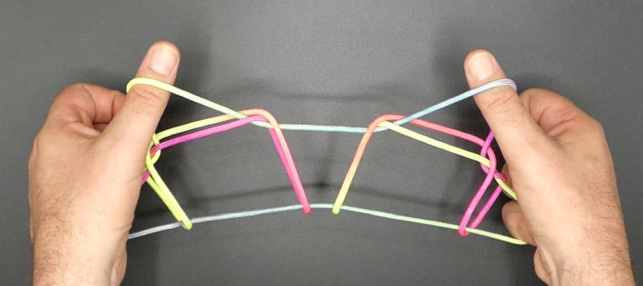
1. Opening A.
2. With 1 from below remove 2 loop.
3. With 2 from above remove 5 loop.
4. Pass 5, under 2 loop, from below in lower 1 loop, upwards at the far side of upper 1f and from below in 2 loop, then hook down 2n (through lower 1 loop), closing 5 to the palm.
5. With 3 from below share 2 loop, then pass 23 over upper 1 loop and pinch lower (TV) 1n between tips of 23 (2 at its near, 3 at its far side). Pass 23 away from the body over upper 1 loop and through 23 loop (which slips off) and up. Separate 2 and 3.
6. Allow the lower 1 loop to slip over upper 1 loop and off 1.
7. With R1 from below share L1 loop. Remove L1 from the figure then with L1 from below share double R1 loop.
8. Pass 2 between upper and lower 1f and bring along the original 2 loop so that it is at the near side of upper and lower 1f, then pass 2 under double 1n to the near side of the figure. Straighten 2 and release double 1 loop.
9. With 1 pick up upper 2n.
10. Remove 2 from the figure and extend, palms facing each other, 1 pointing away from the body, 5 being crooked.

