P002. Kitikmeot 14

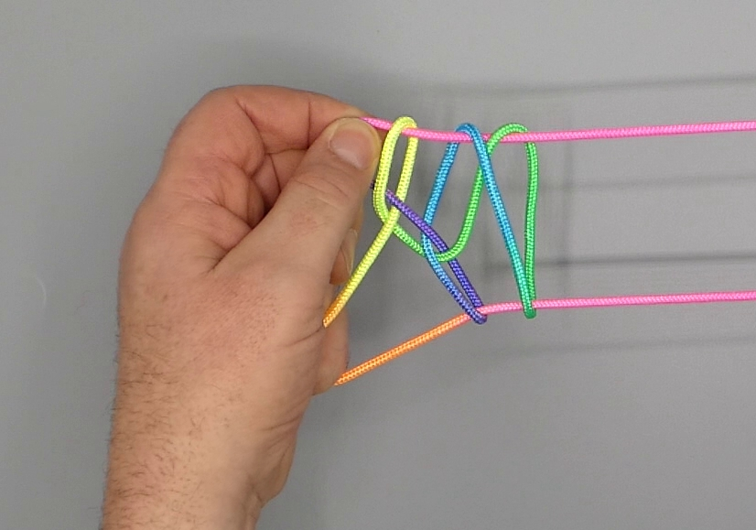

1. Hold both strings of the loop between the sides of L1 and L2 so that some 10 cms of the loop fall down on the near side of L1, forming a hanging loop.
2. With R1 and R2, towards the floor, enter the hanging loop. With R1 from the below side pick up the lower L1f string and with R2 from above hook up the upper L1f string, bringing them through the hanging loop. Do not extend hands completely, just bring RH some 7 cms away from LH.
3. With R345, from the right, grasp the two strings at the other end of the loop at a point below the hanging loop; close R345 to the palm.
4. Rotate L1 away from the body, down, towards the body under all intermediate strings and up.
5. Pass L5 towards the body over all strings, then with L5 hook R1n, return over intermediate strings to the far side of the figure and close L5 to the palm.
6. With L2 from below share double L1 loop, then bring tips of L12 and R2 together. With L12 from above pinch R2f, L1 at its near, L2 at its far side.
7. Remove R2 from the figure, then with L12 pull the string they hold to the left through the double L12 loop, which slips off.
8. Release R1 loop and extend, bringing RH some 20 cms to the right, keeping tension in the strings by allowing the loop grasped with R345 to slip in its grip. With R23 towards the body separate framing strings. With R1 from above (= away from the body) share R23 loop to enlarge it.

