P001. Kitikmeot 7
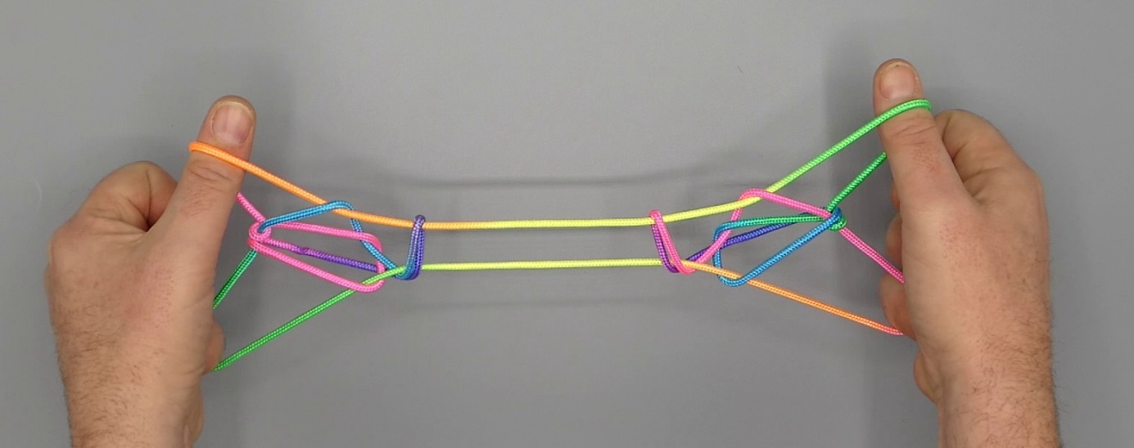
1. Opening A.
2. With 1, over intermediate strings, pick up 5n.
3. Pass 2345 from above in double 1 loop, hooking down intermediate strings and closing 2345 to the palm.
4. Slightly raise 2 and bring it between upper and lower 1n to the near side of the figure. Pinch lower (TV) 1n between tips of 23, then turn 23 away from the body under upper 1n and up over intermediate strings, at the same time straightening 45.
5. Remove 1 from the figure.
6. With 1 from below remove double 2 loop.
7. With 2 from above remove 5 loop.
8. Pass 5 from below in double 1 loop close to 1, then from below in 2 loop, and hook down 2n through double 1 loop, closing 5 to the palm.
9. With 3 from below share 2 loop close to 2, then pass 23 towards the body over all intermediate strings and trap upper 1n (a TV string) between the tips of 23 (2 passing over, 3 passing under upper 1n). Return by rotating 23 down, away from the body through the 2 loop (which slips off 2) and up to create a new 2 loop. Remove upper 1 loop and separate 2 and 3 of each hand.
10. R Katilluik (With R1 from below share L1 loop. Remove L1 from the figure then with L1 from below share double R1 loop. With 1 pick up 2n close to 2, then Navajo 1 by bending 1 towards each other over upper 1n, down towards the body under middle and lower 1n and up. Release 2 loop).
11. Extend, palms facing each other, 1 pointing upwards, 5 being crooked. With tips of 23 adjust the figure so that the two halves of the figure separate in the middle and move towards the hands.

