JST3. Napirraqtuq (“caught in a lasso”)
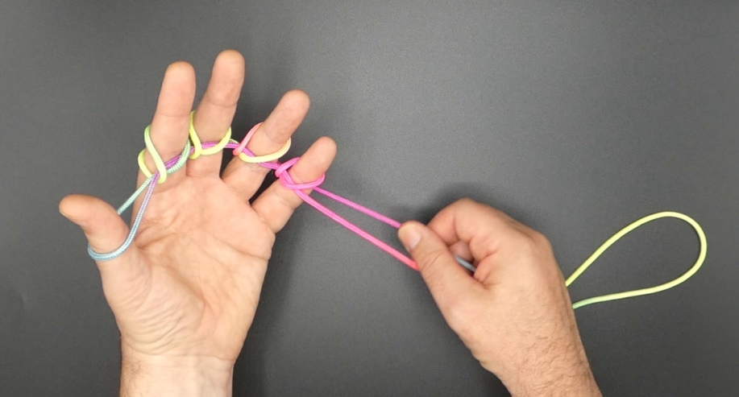
As performed by Susie Apiana

1. Hold LH with its palm facing the body, fingers pointing towards the right, and place a string loop over L12345, so that a pending loop hangs down from the LH. There is a near (palmar) and a far (dorsal) pending string.
2. Pass R2 under near pending string, then over far pending string between L1 and L2, and hook up far pending string, passing R2 down, towards the body under near pending string and up (introducing a half twist in the newly formed R2 loop. With tips pointing towards each other transfer R2 loop to L2. With help of the RH pull far pending string tight towards the floor.
3. Movement 2 between L2 and L3 and transferring R2 loop to L3.
4. Movement 2 between L3 and L4 and transferring R2 loop to L4.
5. Movement 2 between L4 and L5 and transferring R2 loop to L5.
6. Release L1 loop.
7. With RH slowly pull near pending string down towards the floor. The string loop comes off the LH.

